Write a mapreduce job that takes configuration from command line (min.word.count). Based on the configuration, it should perform count of words from a document and produce only those words in the output whose count is greater than or equal to the configuration.

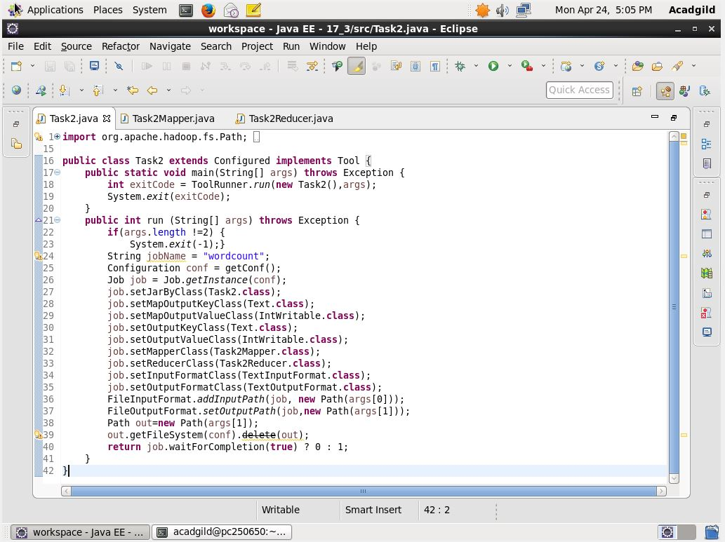

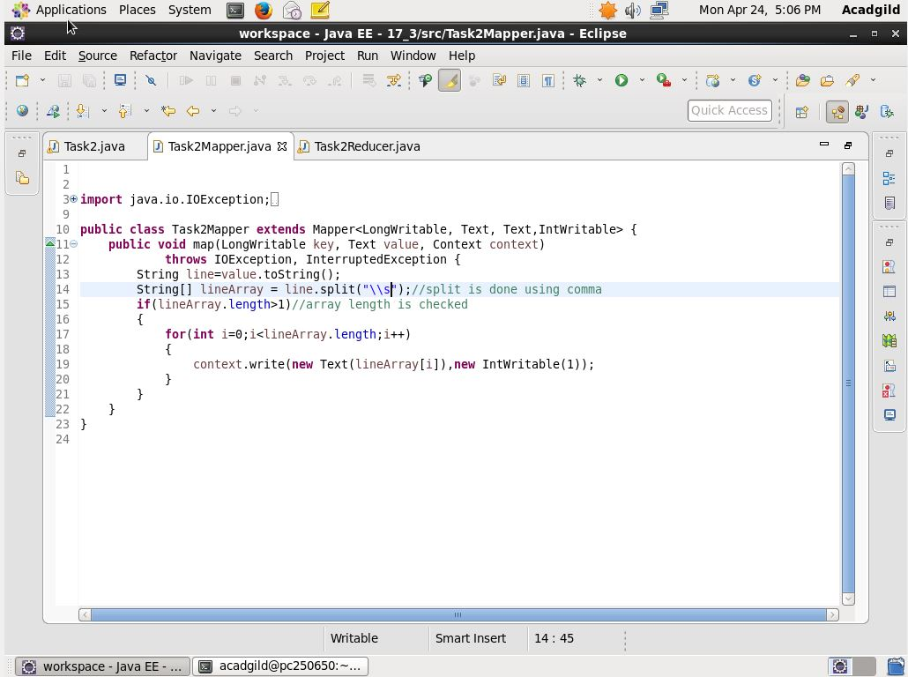

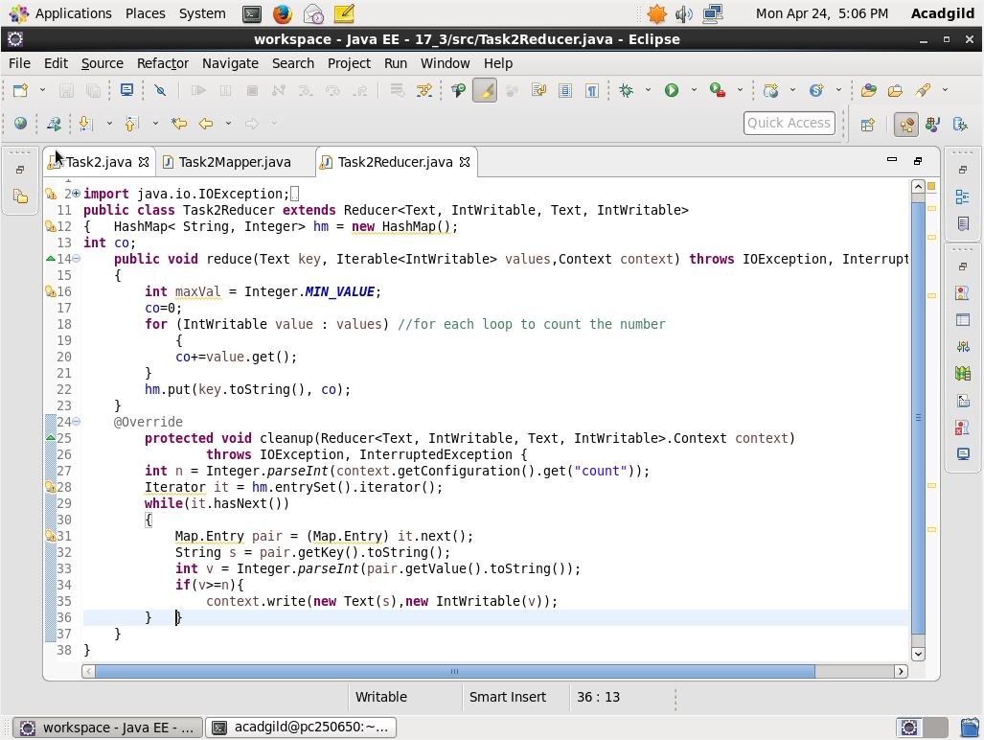

Here the count is given above 33 so the count of the word wonderful is displayed as the count is greater than the 33.

The command used to execute the jar is

Hadoop jar 17_3.jar –D count=33 ‘/user/acadgild/word.txt’ /user/acadgild/17_3

